Readme

This front end is built based on Pycharm (django) and mysql.

The environment is in <https://drive.google.com/drive/folders/1K_mzwjJfUWk-oxXQ1m_-TbKBjrbiBJKR?usp=sharing> and the project is in pythonProject package.

Interpreter: Python 3.8

Packages requirement:

asgiref==3.5.0

backports.zoneinfo==0.2.1

Django==4.0.3

mysqlclient==2.1.0

plotly==5.7.0

six==1.16.0

sqlparse==0.4.2

tenacity==8.0.1

Please run this project on pycharm

To re-run this project:

1. Change the path of the dataset.

Data Source: https://drive.google.com/file/d/1k4XSZeyNO7ZEdn90TZo9WADNjZqxb6H2/view?usp=sharing

1. Run the sql file to create the database and all the features.  
   Please notice, because this data is really big, before you run this file, change run timeouts in the preference of your workbench to a bigger time and reboot the workbench.
2. Adjust the settings.py in pythonProject based on your database connections  
   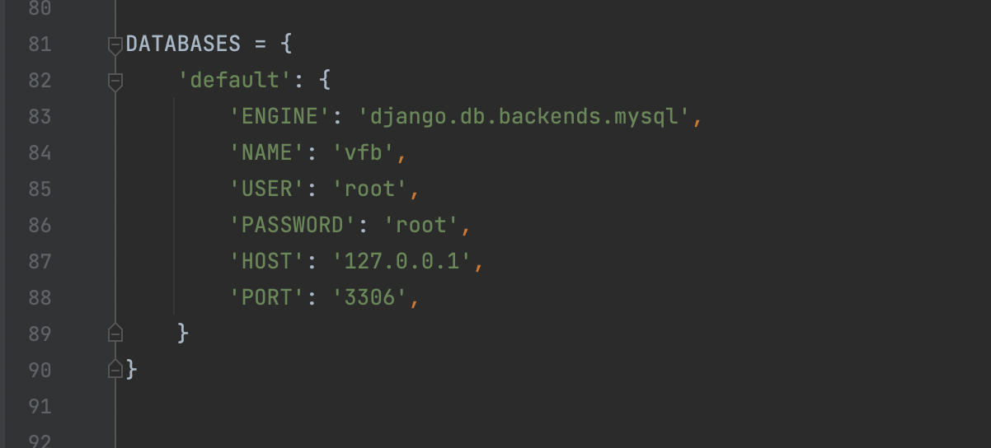
3. In Pycharm terminal, cd to vfb folder, then run the following code:

python manage.py migrate

python manage.py runserver

1. Click the url which terminal provide to you

If you are using Mac M1:

You may need to do the following steps in Pycharm terminal

1. [**https://brew.sh/**](https://brew.sh/) **copy and run in terminal**
2. eval $(/opt/homebrew/bin/brew shellenv)
3. **brew install mysql**
4. arch -arm64 brew install mysql
5. pip install mysqlclient